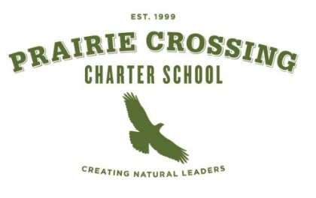

PCCS Board of Directors,

Outreach Committee Meeting Minutes
Tuesday, December 9, 2025 @ 6:00 pm
Wright School House/Library
1571 Jones Point Rd
Grayslake, Il. 60030

Committee Present |  |  | Staff Present
Rebekka Herrington | Gabi White | Meghan Dawson | None
Rebecca Daughtery
Call to Order at 6:07 pm

Public Comment
No Public Present

Discussion Items
- Update on Pillars – Gabi is still reviewing and editing pillars
Communication should be the overarching base of all of the pillars with ideas floated of Board meetings potentially being streamed live, creating updates to the website and having a Board section in the School’s Friday Newsletter.

Attract Retain – reviewed pillar to capture verbiage of:
Become the center of the community/ Build relationships & partnerships
Promote enrollment/ Engage community, parents & staff/ Gather input from community,
parents & staff and Recruit board & committee members

Educate and Celebrate – reviewed pillar to capture:
Internal & external stakeholders/Provide families with the right information about Charter Schools
Educate about the board & committees/ School history/ Education for Sustainability
Highlight student & school success/ Highlight staff achievement

- Update ByLaws and Board Policy. Current Bylaws and Board Policy 200.24 will need to updated to reflect committee structure and purpose. Rebekka suggested bring the document to the board as touch point to ensure we are all moving in same direction and to look for additional feedback and bring any policy or bylaw suggested changes to the Governance Committee for review.

- Review Minutes from Previous Meetings
No comments made on previous meeting minutes

Action Items
1A A motion was made by Rebekka Herrington to move pillars for presentation to the board – Gabi seconded – all ayes. Gabi will present to the board at the next board meeting.

New Business

Adjourn
Motion to Adjourn made by Rebekka Herrington , seconded by Meghan Dawson - All ayes
Meeting adjourned at 7:53PM
Thank you for attending the meeting of the PCCS Board of Education. Individual board members do not respond to public comment. For questions or comments, please e-mail the Board at board@pccharterschool.org. Board e-mails are received and responded to by the Board President.

The PCCS Outreach consists of:

Chair: Gabi White Rebekka Herrington Rebecca Daughtery Meghan Dawson

