The Green Team wishes everyone a happy spring! This newsletter contains tips and tricks to help with some common spring tasks like spring cleaning and getting your garden started. Enjoy!
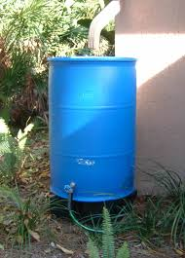
Rain Barrels
Would you like to pay less for your water bills? By collecting water in a rain barrel, you can cut down your cost. Rain barrels conserve water and help the environment. It can be a fun craft to make with your family or for others. Instructables has directions to create different types of rain barrels that meet a variety of aesthetic and price criteria. Simply search for “rain barrel” in the webpage! When you’re finished making your barrel, you can paint it so it looks great in your yard.

Join us April 4 for Planting and Cooking With Herbs
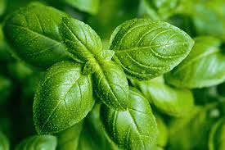
This program will help you spice up your life by adding fresh herbs into your meals. It will cost $10 per family. There will be an extra cost for 6 people or more. You will be planting herbs and cooking. You can take your herbs home!
Who: PCCS families and friends
Where: Prairie Crossing Charter School (Muir Hall)
When: April 4th 4:00 pm - 5:30 pm
How: RSVP required; space is limited!
Email Naomi at nhershiser@pccharterschool.org
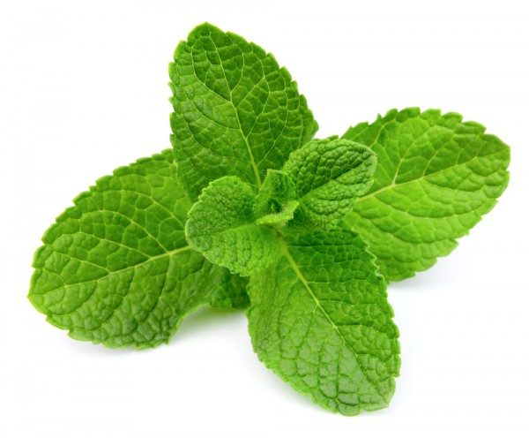
We hope to see you there! Here’s a preview recipe:

Recipe: Strawberry Mint Smoothie
From the Kitchen Of: Prairie Crossing Green Team
Ingredients:
- 8 ounces strawberries (hulled and frozen)
- 1/2 C vanilla yogurt
- 1 C milk (skim, reduced fat, whole, or even try non-dairy!)
- 1 T honey
- 10-12 leaves fresh mint
Directions:
- Place all ingredients in a high powered blender.
- Process until fully blended and smooth.
- Taste test and adjust ingredients, if necessary.
- Pour into glasses and serve immediately.
(Remember to sip with a re-usable straw!)

Look for more information about our May programs coming soon!
Adopt-a-Highway Clean-up, May 12, 2 pm; and Family Campfire, May 18, 6:30 pm!
PCCS is Still Recycling Plastic Bags!
Recycle your plastic bags at PCCS! There are 3 collection boxes around campus. Look for them in the Comstock, Carson & Kennicott buildings.

You can recycle many different plastics: cereal bags, bread bags, plastic packaging pouches (popped), bubble wrap, ice bags, case overwrap, dry cleaner bags (without the hanger please!), produce bags, but WITHOUT FOOD or CRUMBS! The Green Team can not take any food-contaminated or wet plastic for recycling. Some non-recyclable bags come with foil lining, like chip bags or dog-food bags. The planet thanks you for your help!

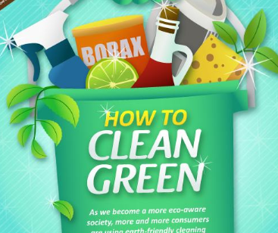
Natural Eco Friendly Cleaners
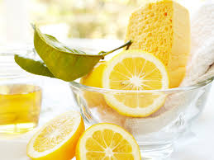
Eco friendly cleaners are not harmful for the environment. You probably already have a lot of these common household items that can help clean your home. CLICK HERE to learn more.

This article reveals the 6 ingredient that can clean almost anything (and how). HERE is another good website for eco friendly cleaning supplies. It even has a guide to natural laundry stain removers. You can use them on almost any occasion of stain removal.
- Tea or Coffee Stains: Immediately pour boiling water over the stain until it is gone, or if it is already set, scrub with a paste of borax and water and wash immediately.
- Grass stains: Scrub with liquid dish soap or treat with a 50/50 Hydrogen Peroxide (3%) and water mix
- Mud stains: Let dry and brush off what you can, then scrub with a borax/water paste and wash immediately
- Food Stains: Treat with a mix of 50/50 Hydrogen Peroxide and water and soak.
- Grease and Oil Stains: Sprinkle the stain with dry baking soda to remove any loose oil or grease and brush off. Then, soak in undiluted white vinegar for 15 minutes, rinse and scrub with liquid dish soap before washing.

Natural Weed Killers
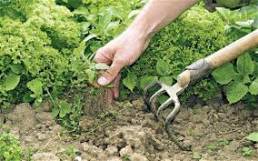
Spring is on its way, and unfortunately weeds will start to appear.There are natural ways to prevent weeds from growing. Combine the ingredients below in a spray bottle and treat weeds at the sunniest time of day for best results.
- 1 gallon white vinegar
- 1 cup salt
- 1 tablespoon liquid dish soap
Here are three items that will eliminate crabgrass :
- Iodized salt
- White distilled vinegar
- Baking soda

